Global System for Mobile Communication based Automatic Alarm System for Disaster Management

Vibhu Singh
Department of Computer Science & Engineering
Sharda University
Greater Noida,India
2018006666.vibhu@ug.sharda.ac.in
Karan
Department of Computer Science & Engineering
Sharda University
Greater Noida,India
2018014809.karan@ug.sharda.ac.in
Vansh Panwar
Department of Computer Science & Engineering
Sharda University
Greater Noida,India
2018012744.vansh@ug.sharda.ac.in

Dr Mandeep Kaur
Department of Computer Science & Engineering
Sharda University
Greater Noida,India
mandeep.kaur@sharda.ac.in

Dr Nitin Rakesh
Department of Computer Science & Engineering, School of Engineering & Technology, Sharda University
Greater Noida, India
nitin.rakesh@gmail.com
Dr Parma Nand
Department of Computer Science &
Engineering, School of Engineering &
Technology, Sharda University
Greater Noida, India
parma.nand@sharda.ac.in

Abstract— Gas leakage is a major problem which causes vulnerable accidents in the domestic areas, residential premises, industrial sector, etc. Among many other applications, home Security is one of the major concerns due to the increase usage of LPG pipelines. The gas leakage has become a common issue. In homes, Liquefied Petroleum gas (LPG) is a known fuel source that is used especially in urban areas. The add-on advantage is its cleanliness as compared to wood and coal. Gas leaks are a source of great concern among residences, studios and vehicles like buses and gas-powered vehicles. The purpose of this paper is to discuss the functioning, design and the future of the automatic gas leak detection system that also alert the user by sending a message using the GSM module, ring buzzer alarm to alert people present locally at the location and control gas leakage (by exhaust functionalities). The another aim is to promote the use of such automatic gas leak protection system based on a gas sensor that can easily detects gas leaks like LPG, smoke, etc. A straightforward way to prevent gas-related hazards is to install and deploy a gas leak detection system or kit as proposed work, in high-risk areas.
Keywords— GSM, Gas Leakage, Arduino, Buzzer, Disaster System, LPG

Introduction
Nowadays, Gas leakage is a serious problem which is seen in many places such as factories, residential areas and vehicles of Compressed Pressure Natural Gas (CNG) such as cars, buses, etc. It has noticed from past that a catastrophic situation occur due to gas leaks. Liquefied petroleum gas (LPG) is a mixture of butane, propane, pentane (50%, 48%, 2%) [1]. It is used as fuel for home appliances, vehicles, and heating purposes. For the cooking purpose, mainly Liquefied petroleum gas (LPG) is used. These gases catch fire easily due to any leakage that further may lead to an explosion. Also it leads to many accidents that may result in damage and loss of material possessions. The death toll is rising as a result of the LPG outbreak and the threat to human health has increased in recent years [2].

Reason for such an explosion is due to no regular checking of a gas cylinder, a lack of awareness, substandard cylinder, and worn-out regulator. To avoid this problem, the project entitled “LPG Leakage Detector”, to provide maximum assistance during the prevention of any explosions and hazards caused by gas leaks [3].
The objective of the proposed work is gas leakage detection and altert the users about the gas leakage so as to prevent the occurrence of an accident.The objectives of the proposed work are to design/built a GSM(Global System for Mobile communication) based automatic alarm system for disaster management, at a minimal cost with providing maximum benefits. Also it will detect gas leakage like LPG using LPG gas sensor using Arduino. A Buzzer-produce alert sound on gas leakage and Red LED (Light-emitting Diode) will on when system detect gas leakage. Then with the help of GSM module, a message will be sent to the use. The exhaust fans will automatically turn on whenever the gas leakage detected. Lastly, it will connect to nearby fire departments and get a call back from fire extinguishing department to the owner as soon as possible to take further steps of prevention.

Literature Survey
This section elaborates the existing solutions with specific objectives identifed. The table 1 shows the results and findings of the work done by various researchers.

Table 1: Existing Systems

S.N0. | OBJECTIVE | RESULT | FINDINGS
1 | The system used star type topology for devices. Through gateway node with XBee network, all the sensors and devices are controlled. This helps in providing safety measures against serious risk. | The gas leakage response can be obtained and send to the mobile users. The information is also displayed on the monitoring system. | Here visual LabVIEW approach is used in the area of gas leakage detection [4]
2 | In this paper, power efficient with low cost gas leakage detection system is described that consist of centralized alarm and gas detector. | The paper presented the design, development and  implementation of low power, accurate LP gas | Surface mount level PCB was designed as the  final product without modules and kits, Two modules were designed and implemented in  printed circuit board [5]
3 | Here an arduino and zigbee based wireless gas leakage monitoring system is introduced. | The system is designed in such a way that the sensor is deployed near to gas pipeline so as to receive immediate response. | Used LabVIEW GUI and Zigbee transceiver with LCD display, buzzer alarm system to implement the autonomous exhaust system [6]
4 | Toxic gas detection and alert system that is based on microcontroller | It is more efficient OS because of it connected to the web page. | This system reduces the accident occur by gas leakage [7]
5 | Design of an SMS based alert system | Infrared sensor based gas wastage monitoring | People could easily use their time effectively [8]
6 | A IoT based automatic gas leak control system to alert and detect gas leaks | Arduino with an integrated microcontroller system is used for detection | Mainly used to alert users about gas leakage to avoid fire accidents [9]
7 | A gas leakage detection system is proposed to automatically detect, alert and control gas leakage | Here MQ-6 sensor is used. The microcontroller senses the presence of a gas and gives an audiovisual alarm. | Mainly helpful in reducing accidents caused by gas leakage [10]
8 | A microcontroller based toxic gas detection and alert system | Here a buzzer and LED is used to altert the users about the gas leakage when the gas exceeds the normal level. An alert message is also sent to the authorized person. | This system helped in providing safety against the leakage of harmful and toxic gases [11]

Methodology
Working of MQ-6 sensor Module; Easy to use liquefied petroleum gas (LPG) sensor, ready to detect LP GAS (mostly composed of butane and propane) in the air. MQ6 sensor can detect gas anywhere within range of 200 to 10000 ppm [12]. It is the main sensing component that is used in a gas detection appliance. The sensor consists of a sensing material that ionizes the gases which come in its contact. As a result, the ionization of the gases changes the resistance across the circuit. The only limitation of this sensor is that it has less sensitivity towards alcohol and smoke [3] [4] [14].
This framework depends on Arduino Nano, Gas sensor(MQ-6), photoelectric detector, GSM module, and an exhaust fan. At the point where the sensor points for gas in the weather, (it will give 1 computerized yield and if the gas is unknown the sensor will give an advanced yield 0. Arduino will get the sensor yield as computerized input.) In the event that the sensor output is high, then the device will start tuning next to the LCD which will indicate "Gas recognition: Yes".With the help of the GSM module alert message send to the user and near a gas station and simultaneously exhaust system will work. In the event that the sensor yield is low then the ringer won't tune, and the LCD which will indicate "Gas distinguished: No" [12] [15] [16] . The device usually includes various switches or sensors connected to the control unit that figures out any catch is pushed or that the set time has elapsed, and it usually illuminates the catch value lamp or control board, and sounds the discipline as a constant or abnormal rumbling or screaming noise. With a sensory-based gas system spillage identifier and caution framework, the accompanying equipment parts are required. The gadget is versatile, lightweight, easy to understand, and proficient with multi-useful highlights [13] [17] [18].

System Analysis & Design
This section discusses the hardware and software requirements of the proposed work. The hardware requirements of the proposed work are shown in Table 2. Also the proposed work detects the leakage of gas or presence of fire that further activates gas sensor or flame sensor. It also makes calls to the concerned users on their mobile numbers. The circuit simulation diagram is shown in Fig1 and the complete block diagram of the proposed system is shown in Fig2.

Table 2. Hardware Requirements of the Proposed Work
Tools | Amount
Gas sensor (MQ-135) | One
Arduino Nano | One
LCD (16*2) | One
Male to male/female Jumper wire | Forty
Buzzer | One
Battery | One
Gas Lighter | One
Resistor | One
Breadboard | One
Exhaust fan | One
GSM Module | One

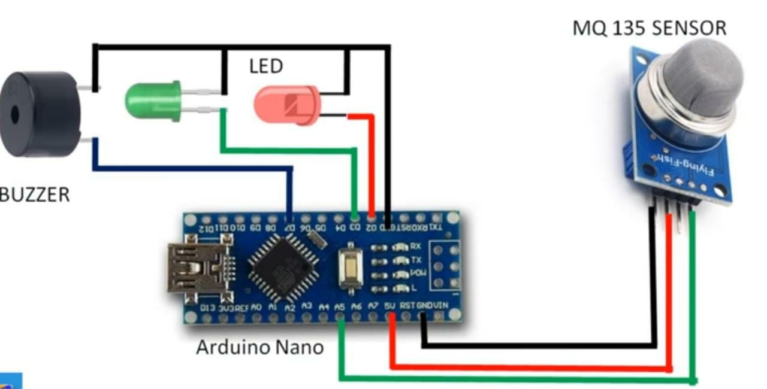
Fig1.Circuit Simulation Diagram

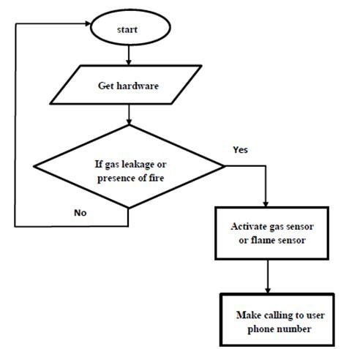

Fig 2. Block Diagram

Results and Discussion
The proposed work has many objectives that have been attained by successfully implementing the system. The objectives are as follows:
- Design an automatic alarm system for disaster management, at a minimal cost with providing maximum benefits.
- Detect gas leakage like LPG using LPG gas sensor and Arduino.
- Buzzer-produce alert sound on gas leakage.
- Red LED will on when system detect gas leakage
Figure 3, 4 (a) & 4 (b) shows the glimpse of the proposed system.

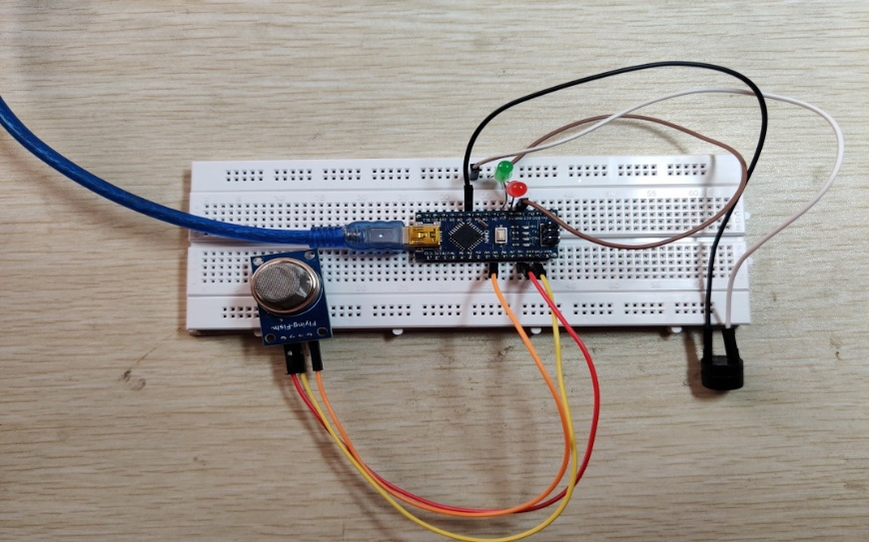
Fig3. Setup Model
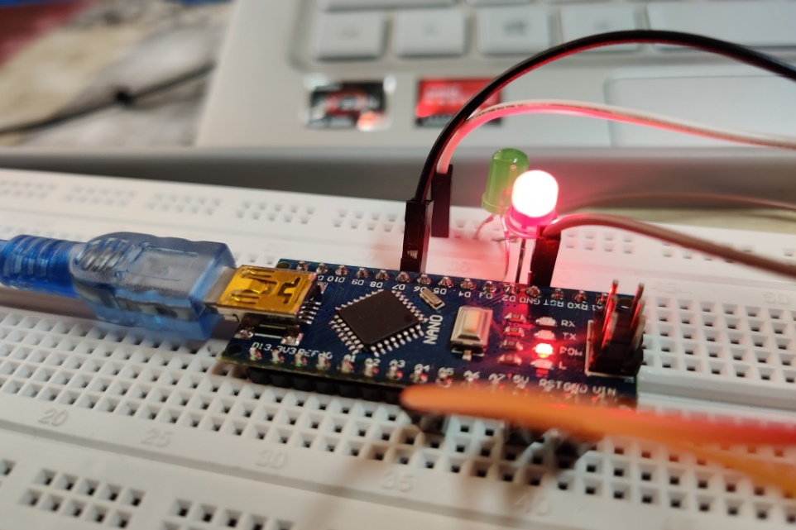
Fig4. Working Model (a)
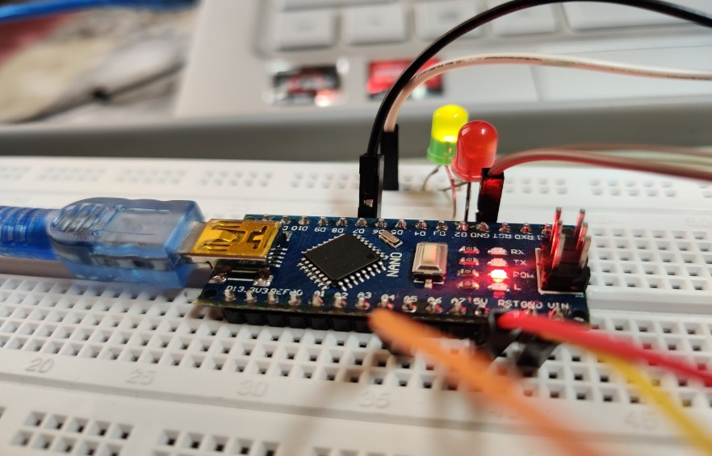
Fig4. Working Model (b)

Conclusion
The LPG is now being used in everywhere – at home, car and even in hospital, hotel etc. There are many cases of major accidents caused by Gas leakage. Since there are provision of ‘Buzzer” as well as “ALERT notification” which is visible in mobile through Bluetooth form some distance, hence its usefulness will be tremendous. With our project we could be able to prevent all types of accidents due to leakage of LPG.

Future scope
Gas monitoring system is a component of Smart Home application, which is being pushed by major Indian towns. The Internet of Things (IoT) transforms a drone into a gas detector. Additionally, an Automatic Shut-off mechanism might be included in the future. When it detects a gas leak, it automatically shuts off the gas supply. In the industrial sector, this method might be deployed, Hotels and other establishments where LPG cylinders are often seen. A wide range of sectors may benefit from this technology. A wide range of businesses including the steel and metallurgical industries use this technology. The proposed solution is applicable in the industries like Food processing businesses, glass and plastics manufacturers, pharmaceuticals, and aerosol manufacturers manufacturing. This technique may help hospitals ensure the safety of their patients to the greatest extent feasible. The cylinders that are utilized in it may be tracked using this method. For example, oxygen cylinders are often used. There is a danger that many pupils are unaware of the likelihood of an accident is quite high. Since our technology may be utilized in schools and universities, it can also be used. Well-regarded schools may be found at many institutions developed labs, such as chemistry laboratories and pharmaceutical laboratories, where gas burners are often utilized. Plenty Gas cylinders are used for medical equipment.

References
- K.Manichandana, Simrah UmmeRuman, Harshavardhini Biderkota, Ms.Pr Anisha, Dr.B V, “Gas Leakage Detection and Smart Alerting System” , ICITAIC-2018.
- Anandhakrishnan S, Deepesh Nair, Rakesh K, Sampath K,Gayathri S NairI, ” IOT Based Smart Gas Monitoring System” , OSR Journal of Electrical and Electronics Engineering (IOSR-JEEE), PP 82-87.
- Prof. Pranay Meshram, Nancy Shukla, Stuti Mendhekar, Renuka Gadge ,Shivani Kanaskar,“IoT Based LPG Gas Leakage Detector”, IJSRCSEIT-2019.
- Mujawar, T. H., et al. "Development of wireless sensor network system for LPG gas leakage detection system." International Journal of Scientific & Engineering Research 6.4, 2015, pp 558-563.
- Wickramasinghe, M. G. D., and N. Abhayasinghe. "LP Gas Leakage Alarm." SAITM Research Symposium on Engineering Advancements. 2013.
- Yan, Huan Hui, and Yusnita Rahayu. "Design and development of gas leakage monitoring system using arduino and zigbee." Proceeding Of The Electrical Engineering Computer Science And Informatics 1.1, 2014, pp 207-212.
- Pandey, Rohan Chandra, et al. "Internet of things (IOT) based gas leakage monitoring and alerting system with MQ-2 sensor." International Journal of Engineering Development and Research 5.2 (2017): 2135-2137.
- Anandhakrishnan, S., et al. "IOT based smart gas monitoring system." IOSR Journal of Electrical and Electronics Engineering (IOSR-JEEE) (2017): 82-87.
- Meshram, Pranay, et al. "IoT Based LPG Gas Leakage Detector." International Journal of Scientific Research in Computer Science, Engineering and Information Technology 5.1 (2019): 531-534.
- Khan, Mohammad Monirujjaman. "Sensor-based gas leakage detector system." Engineering Proceedings. Vol. 2. No. 1. Multidisciplinary Digital Publishing Institute, 2020.
- Manichandana, K., et al. "GLOBAL JOURNAL OF ENGINEERING SCIENCE AND RESEARCHES."
- Rohan Chandra Pandey, Manish Verma, Lumesh Kumar Sahu, Saurabh Deshmukh,” Internet Of Things (IOT) based gas Leakage Monitoring and Alerting System with MQ-6 Sensor” , 2018 IJCRT | Volume 6.
- K.Padma Priya , M.Surekha , R.Preethi , T.Devika , N.Dhivya ,”Smart Gas Cylinder Using Embedded System ”,IJIREEICE,Vol. 2, Issue 2, February 2014.
- Soundarya, T.; Anchitaalagammai, J.V.; Priya, G.D.; Karthickkumar, S.S. C-Leakage: Cylinder LPG Gas Leakage Detection for Home Safety. IOSR J. Electron. Commun. Eng. 2014, 9, 53–58
- Meenakshi, A.A.; Meghana, R.B.N.; Krishna, P.R. LPG Gas Leakage Detection and Prevention System. Int. J. Future Revolut. Comput. Sci. Commun. Eng. 2017, 3, 1–4
- Mahalingam, A., R. T. Naayagi, and N. E. Mastorakis. "Design and implementation of an economic gas leakage detector." Recent Researches in Applications of Electrical and Computer Engineering, pp. 20-24, 2012.
- Attia, Hussain A., and Halah Y. Ali. "Electronic Design of Liquefied Petroleum Gas Leakage Monitoring, Alarm, and Protection System Based on Discrete Components." International Journal of Applied Engineering Research, vol. 11, no. 19, pp. 9721-9726, 2016
- Ashish Shrivastava, Ratnesh Prabhaker, Rajeev Kumar, Rahul Verma, "GSM based gas leakage detection system." International Journal of Emerging Trends in Electrical and Electronics, vol. 3, no. 2, pp. 42-45, 2013.

